Project Development Phase
Model Performance Test

Date | JUNE 2026
Team ID
Project Name | Visualization Tool for Electric Vehicle Charge and Range Analysis
Maximum Marks

Model Performance Testing:
S.No. | Parameter | Screenshot / Values
1. | Data Rendered | 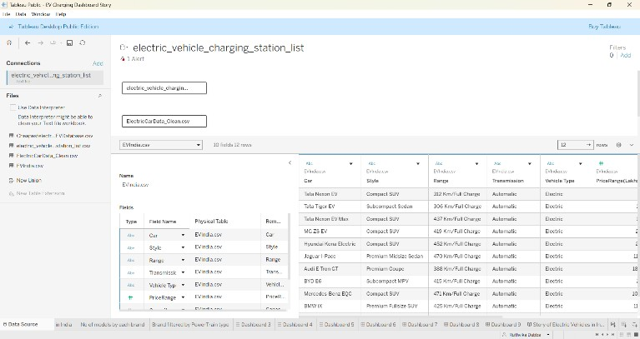
2. | Data Preprocessing | 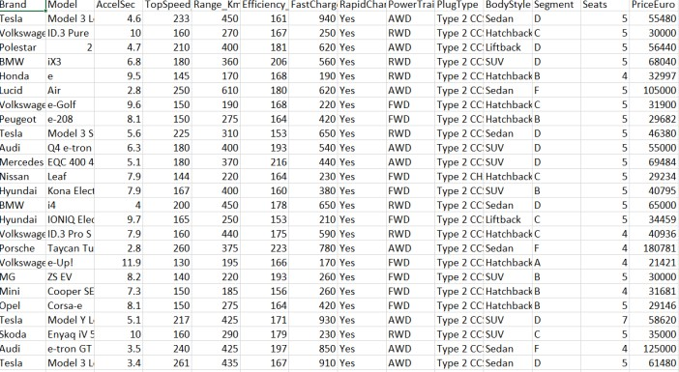

3. | Utilization of Filters | 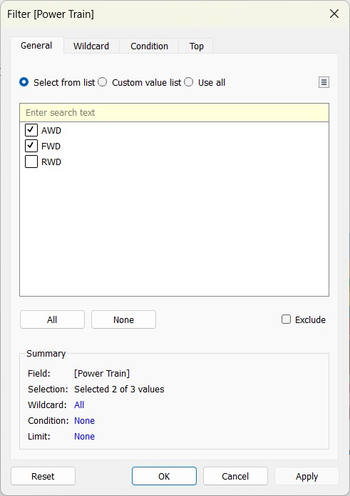

 |  | 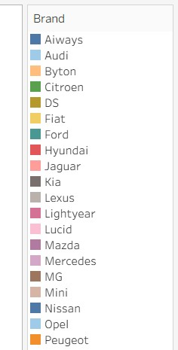
4. | Calculation fields Used | 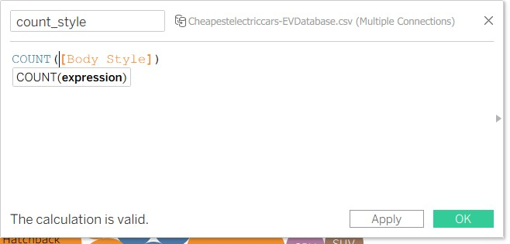
5. | Dashboard design | 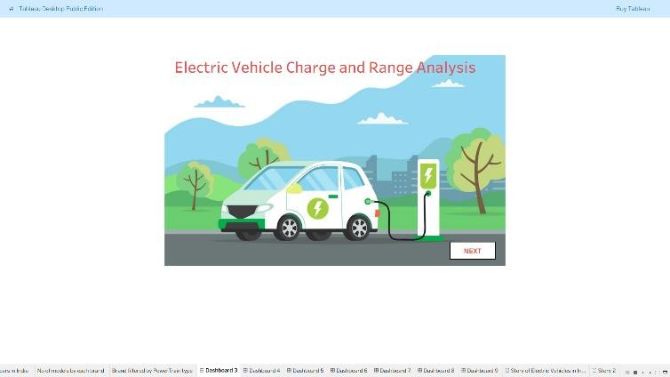  No of Visualizations / Graphs – 9

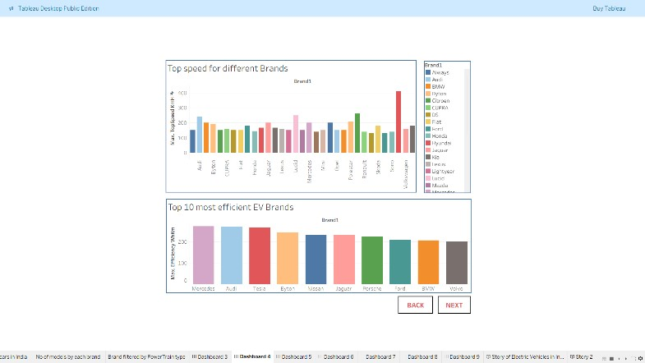
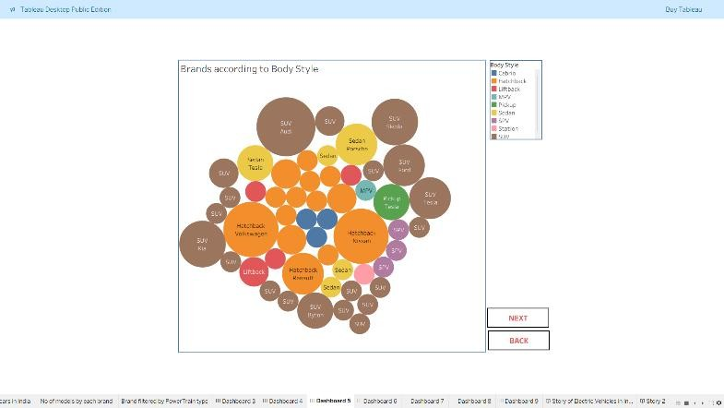

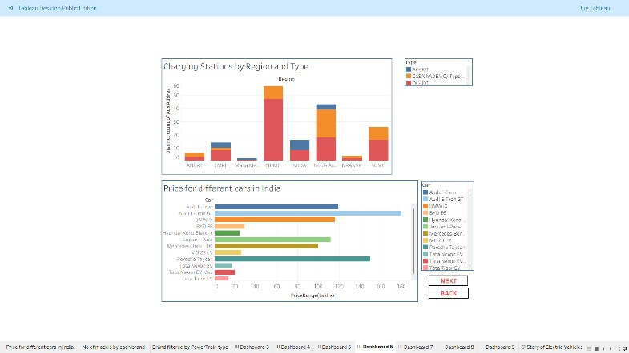
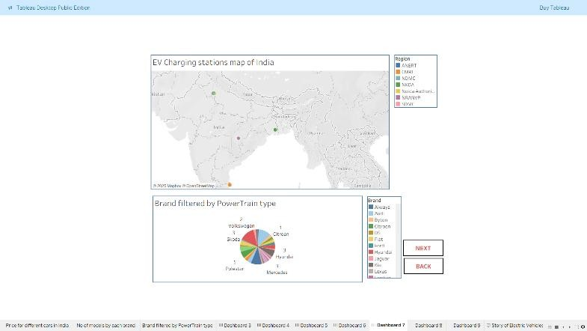
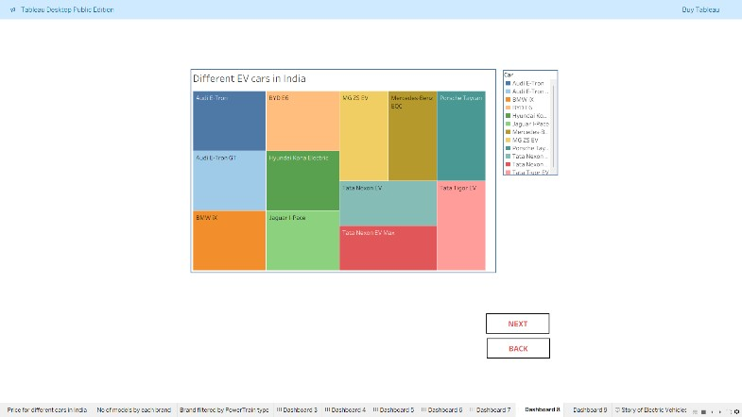
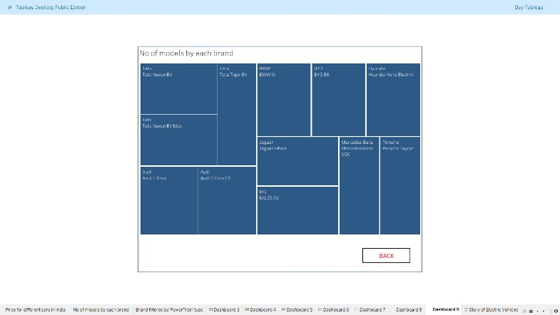
6 | Story Design | No of Visualizations / Graphs – 9  